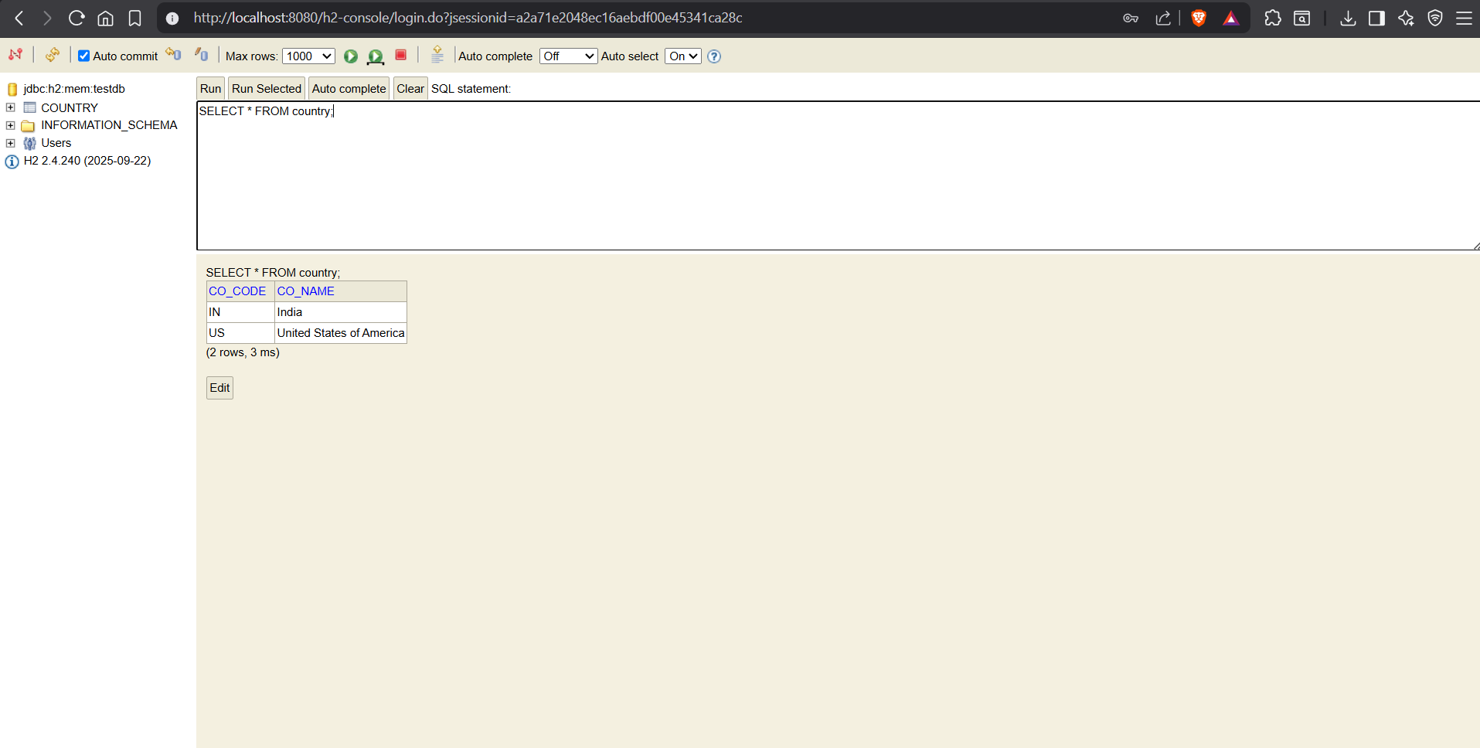
application.properties
spring.application.name=EmployeeManagementSystem
spring.datasource.url=jdbc:h2:mem:testdb
spring.datasource.driverClassName=org.h2.Driver
spring.datasource.username=sa
spring.datasource.password=password
spring.jpa.database-platform=org.hibernate.dialect.H2Dialect
spring.jpa.hibernate.ddl-auto=none
spring.h2.console.enabled=true
spring.h2.console.path=/h2-console
spring.sql.init.mode=always

schema.sql
CREATE TABLE country(
co_code VARCHAR(2) PRIMARY KEY,
co_name VARCHAR(50)
);

data.sql
INSERT INTO country VALUES('IN','India');
INSERT INTO country VALUES('US','United States of America');
Country.java
package com.employee.EmployeeManagementSystem.entity;

import jakarta.persistence.Column;
import jakarta.persistence.Entity;
import jakarta.persistence.Id;
import jakarta.persistence.Table;

@Entity
@Table(name = "country")
public class Country {

@Id
@Column(name = "co_code")
private String code;

@Column(name = "co_name")
private String name;

public Country() {
}

public Country(String code, String name) {
this.code = code;
this.name = name;
}

public String getCode() {
return code;
}

public void setCode(String code) {
this.code = code;
}

public String getName() {
return name;
}

public void setName(String name) {
this.name = name;
}

@Override
public String toString() {
return "Country{" +
"code='" + code + '\'' +
", name='" + name + '\'' +
'}';
}
}
CountryRepository.java
package com.employee.EmployeeManagementSystem.repository;

import com.employee.EmployeeManagementSystem.entity.Country;
import org.springframework.data.jpa.repository.JpaRepository;
import org.springframework.stereotype.Repository;

@Repository
public interface CountryRepository extends JpaRepository<Country, String> {

}
CountryService.java
package com.employee.EmployeeManagementSystem.service;

import com.employee.EmployeeManagementSystem.entity.Country;
import com.employee.EmployeeManagementSystem.repository.CountryRepository;
import org.springframework.beans.factory.annotation.Autowired;
import org.springframework.stereotype.Service;
import org.springframework.transaction.annotation.Transactional;

import java.util.List;

@Service
public class CountryService {

@Autowired
private CountryRepository countryRepository;

@Transactional
public List<Country> getAllCountries() {
return countryRepository.findAll();
}
}

EmployeeManagementSystemApplication.java
package com.employee.EmployeeManagementSystem;

import com.employee.EmployeeManagementSystem.entity.Country;
import com.employee.EmployeeManagementSystem.service.CountryService;
import org.springframework.boot.SpringApplication;
import org.springframework.boot.autoconfigure.SpringBootApplication;
import org.springframework.context.ApplicationContext;

import java.util.List;

@SpringBootApplication
public class EmployeeManagementSystemApplication {

public static void main(String[] args) {

ApplicationContext context =
SpringApplication.run(EmployeeManagementSystemApplication.class, args);

CountryService service =
context.getBean(CountryService.class);

List<Country> countries = service.getAllCountries();

System.out.println(countries);
}
}
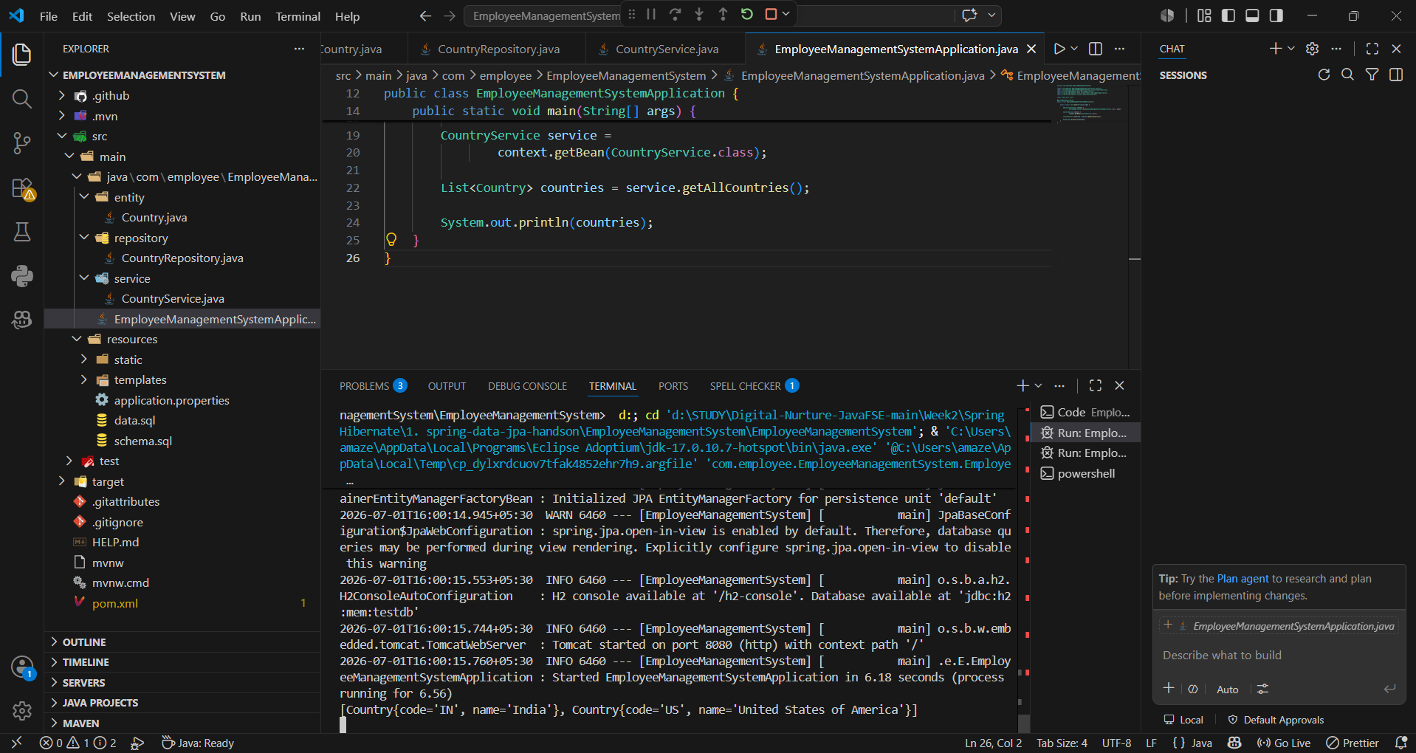

Ex6:
EmployeeManagementSystemApplication.java
package com.employee.EmployeeManagementSystem;

import com.employee.EmployeeManagementSystem.entity.Country;
import com.employee.EmployeeManagementSystem.service.CountryService;
import com.employee.EmployeeManagementSystem.service.exception.CountryNotFoundException;
import org.springframework.boot.SpringApplication;
import org.springframework.boot.autoconfigure.SpringBootApplication;
import org.springframework.context.ApplicationContext;

@SpringBootApplication
public class EmployeeManagementSystemApplication {

private static CountryService countryService;

public static void main(String[] args) throws CountryNotFoundException {

ApplicationContext context =
SpringApplication.run(EmployeeManagementSystemApplication.class, args);

countryService = context.getBean(CountryService.class);

testFindCountry();
}

private static void testFindCountry() throws CountryNotFoundException {

System.out.println("Start");

Country country = countryService.findCountryByCode("IN");

System.out.println(country);

System.out.println("End");
}
}
CountryService.java
package com.employee.EmployeeManagementSystem.service;

import com.employee.EmployeeManagementSystem.entity.Country;
import com.employee.EmployeeManagementSystem.repository.CountryRepository;
import com.employee.EmployeeManagementSystem.service.exception.CountryNotFoundException;
import org.springframework.beans.factory.annotation.Autowired;
import org.springframework.stereotype.Service;
import org.springframework.transaction.annotation.Transactional;

import java.util.List;
import java.util.Optional;

@Service
public class CountryService {

@Autowired
private CountryRepository countryRepository;

@Transactional
public List<Country> getAllCountries() {
return countryRepository.findAll();
}

@Transactional
public Country findCountryByCode(String countryCode) throws CountryNotFoundException {

Optional<Country> result = countryRepository.findById(countryCode);

if (!result.isPresent()) {
throw new CountryNotFoundException("Country Not Found");
}

return result.get();
}
}
CountryNotFoundException.java
package com.employee.EmployeeManagementSystem.service.exception;

public class CountryNotFoundException extends Exception {

public CountryNotFoundException(String message) {
super(message);
}
}
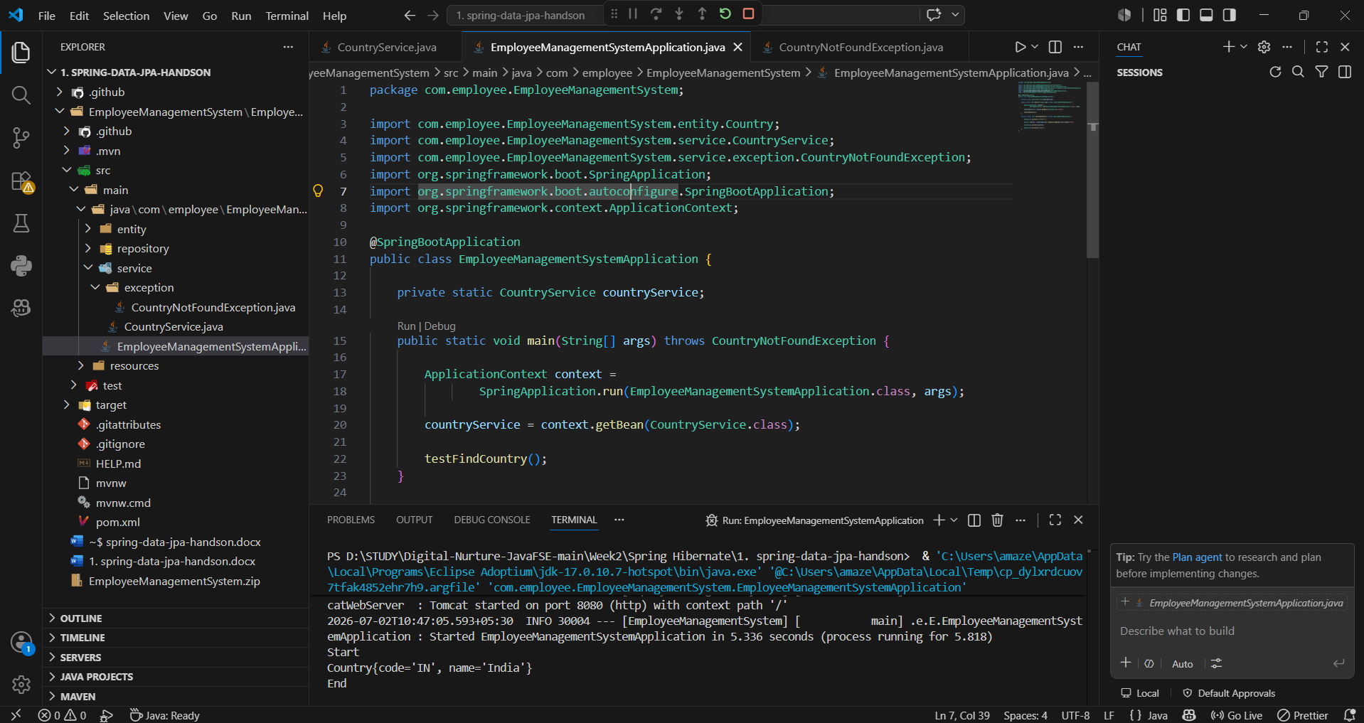

Ex6:
EmployeeManagementSystemApplication.java
package com.employee.EmployeeManagementSystem;

import com.employee.EmployeeManagementSystem.entity.Country;
import com.employee.EmployeeManagementSystem.service.CountryService;
import com.employee.EmployeeManagementSystem.service.exception.CountryNotFoundException;
import org.springframework.boot.SpringApplication;
import org.springframework.boot.autoconfigure.SpringBootApplication;
import org.springframework.context.ApplicationContext;

@SpringBootApplication
public class EmployeeManagementSystemApplication {

private static CountryService countryService;

public static void main(String[] args) throws CountryNotFoundException {

ApplicationContext context =
SpringApplication.run(EmployeeManagementSystemApplication.class, args);

countryService = context.getBean(CountryService.class);

testAddCountry();
}

private static void testAddCountry() throws CountryNotFoundException {

Country country = new Country();

country.setCode("NP");
country.setName("Nepal");

countryService.addCountry(country);

System.out.println(countryService.findCountryByCode("NP"));
}
}
CountryService.java
package com.employee.EmployeeManagementSystem.service;

import com.employee.EmployeeManagementSystem.entity.Country;
import com.employee.EmployeeManagementSystem.repository.CountryRepository;
import com.employee.EmployeeManagementSystem.service.exception.CountryNotFoundException;
import org.springframework.beans.factory.annotation.Autowired;
import org.springframework.stereotype.Service;
import org.springframework.transaction.annotation.Transactional;

import java.util.List;
import java.util.Optional;

@Service
public class CountryService {

@Autowired
private CountryRepository countryRepository;

@Transactional
public List<Country> getAllCountries() {
return countryRepository.findAll();
}

@Transactional
public Country findCountryByCode(String countryCode) throws CountryNotFoundException {

Optional<Country> result = countryRepository.findById(countryCode);

if (!result.isPresent()) {
throw new CountryNotFoundException("Country Not Found");
}

return result.get();
}

@Transactional
public void addCountry(Country country) {
countryRepository.save(country);
}
}
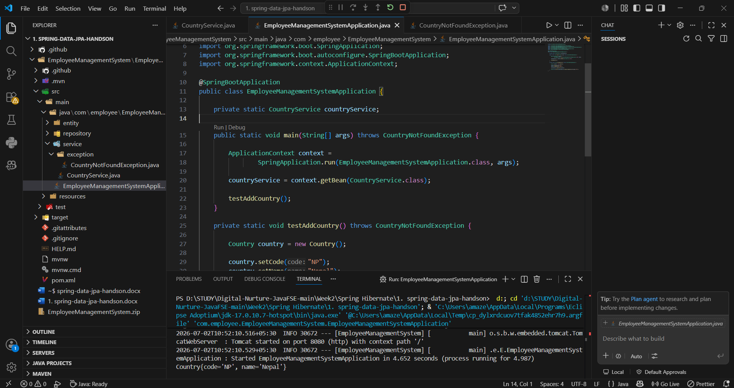

Ex8:
EmployeeManagementSystemApplication.java
package com.employee.EmployeeManagementSystem;

import com.employee.EmployeeManagementSystem.entity.Country;
import com.employee.EmployeeManagementSystem.service.CountryService;
import com.employee.EmployeeManagementSystem.service.exception.CountryNotFoundException;
import org.springframework.boot.SpringApplication;
import org.springframework.boot.autoconfigure.SpringBootApplication;
import org.springframework.context.ApplicationContext;

@SpringBootApplication
public class EmployeeManagementSystemApplication {

private static CountryService countryService;

public static void main(String[] args) throws CountryNotFoundException {

ApplicationContext context =
SpringApplication.run(EmployeeManagementSystemApplication.class, args);

countryService = context.getBean(CountryService.class);

testUpdateCountry();
}

private static void testUpdateCountry() throws CountryNotFoundException {

countryService.updateCountry("IN", "Bharat");

Country country = countryService.findCountryByCode("IN");

System.out.println(country);
}
}
CountryService.java
package com.employee.EmployeeManagementSystem.service;

import com.employee.EmployeeManagementSystem.entity.Country;
import com.employee.EmployeeManagementSystem.repository.CountryRepository;
import com.employee.EmployeeManagementSystem.service.exception.CountryNotFoundException;
import org.springframework.beans.factory.annotation.Autowired;
import org.springframework.stereotype.Service;
import org.springframework.transaction.annotation.Transactional;

import java.util.List;
import java.util.Optional;

@Service
public class CountryService {

@Autowired
private CountryRepository countryRepository;

@Transactional
public List<Country> getAllCountries() {
return countryRepository.findAll();
}

@Transactional
public Country findCountryByCode(String countryCode) throws CountryNotFoundException {

Optional<Country> result = countryRepository.findById(countryCode);

if (!result.isPresent()) {
throw new CountryNotFoundException("Country Not Found");
}

return result.get();
}

@Transactional
public void addCountry(Country country) {
countryRepository.save(country);
}
@Transactional
public void updateCountry(String code, String name) throws CountryNotFoundException {

Country country = findCountryByCode(code);

country.setName(name);

countryRepository.save(country);
}
}
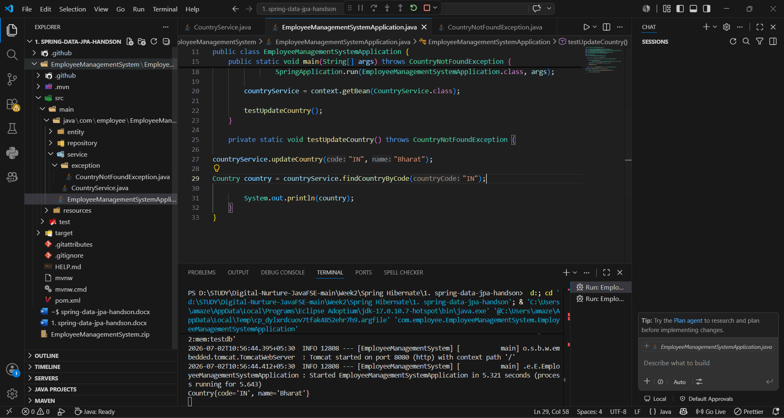
Ex9:
EmployeeManagementSystemApplication.java
package com.employee.EmployeeManagementSystem;

import com.employee.EmployeeManagementSystem.entity.Country;
import com.employee.EmployeeManagementSystem.service.CountryService;
import com.employee.EmployeeManagementSystem.service.exception.CountryNotFoundException;
import org.springframework.boot.SpringApplication;
import org.springframework.boot.autoconfigure.SpringBootApplication;
import org.springframework.context.ApplicationContext;

@SpringBootApplication
public class EmployeeManagementSystemApplication {

private static CountryService countryService;

public static void main(String[] args) throws CountryNotFoundException {

ApplicationContext context =
SpringApplication.run(EmployeeManagementSystemApplication.class, args);

countryService = context.getBean(CountryService.class);

testDeleteCountry();
}

private static void testDeleteCountry() {

Country country = new Country();
country.setCode("NP");
country.setName("Nepal");

countryService.addCountry(country);

countryService.deleteCountry("NP");

try {
System.out.println(countryService.findCountryByCode("NP"));
} catch (CountryNotFoundException e) {
System.out.println("Country deleted successfully");
}
}
}
CountryService.java
package com.employee.EmployeeManagementSystem.service;

import com.employee.EmployeeManagementSystem.entity.Country;
import com.employee.EmployeeManagementSystem.repository.CountryRepository;
import com.employee.EmployeeManagementSystem.service.exception.CountryNotFoundException;
import org.springframework.beans.factory.annotation.Autowired;
import org.springframework.stereotype.Service;
import org.springframework.transaction.annotation.Transactional;

import java.util.List;
import java.util.Optional;

@Service
public class CountryService {

@Autowired
private CountryRepository countryRepository;

@Transactional
public List<Country> getAllCountries() {
return countryRepository.findAll();
}

@Transactional
public Country findCountryByCode(String countryCode) throws CountryNotFoundException {

Optional<Country> result = countryRepository.findById(countryCode);

if (!result.isPresent()) {
throw new CountryNotFoundException("Country Not Found");
}

return result.get();
}

@Transactional
public void addCountry(Country country) {
countryRepository.save(country);
}
@Transactional
public void updateCountry(String code, String name) throws CountryNotFoundException {

Country country = findCountryByCode(code);

country.setName(name);

countryRepository.save(country);
}
@Transactional
public void deleteCountry(String code) {
countryRepository.deleteById(code);
}
}
